**Project Planning Phase**

**Project Planning Template (Product Backlog, Sprint Planning, Stories, Story points)**

|  |  |
| --- | --- |
| Date | 21 October 2023 |
| Team ID | NM2023TMID05047 |
| Project Name | The Future of Work : Glassdoor Jobs |
| Maximum Marks | 8 Marks |

**Product Backlog, Sprint Schedule, and Estimation (4 Marks)**

Use the below template to create product backlog and sprint schedule

|  |  |  |  |  |
| --- | --- | --- | --- | --- |
| **Sno** | **Sprint** | **Member Names** | **Description** | **Date** |
| **1** | **Sprint 1** | SAMSUDEEN SHA A | **Data Collection and Ingestion** | **Sep 20 - 2023** |
| **2** | **Sprint 2** | SANTHOSH KUMAR S | **Data Processing and Analysis** | **Sep 22 - Sep 26, 2023** |
| **3** | **Sprint 3** | **SANJEEV P , SAKTHI GANESH** | **User Interface Design and Visualization** | **Sep 26 - Oct 1, 2023** |
| **4** | **Sprint 4** | SAMSUDEEN SHA A | **Data Integration and Framework Modeling** | **Oct 1 - Oct 6, 2023** |
| **5** | **Sprint 5** | SAMSUDEEN SHA A , SANJEEV | **User Authentication and Security** | **Oct 8 - Oct 14, 2023** |
|  |  |  |  |  |
| **6** | **Sprint 6** | SAKTHI GANESH , SANTHOSH KUMAR | **Reporting and Dashboard Development** | **Oct 15 - Oct 18, 2023** |
| **7** | **Sprint 7** | SAMSUDEEN SHA A | **Testing and Quality Assurance** | **Oct 19 - Oct 24, 2023** |
| **8** | **Sprint 8** | SANTHOSH KUMAR S | **Deployment and Release** | **Oct 25 - Oct 27, 2023** |
|  |  |  |  |  |

|  |  |  |  |  |  |  |
| --- | --- | --- | --- | --- | --- | --- |
| **Sprint** | **Functional**  **Requirement (Epic)** | **User Story**  **Number** | **User Story / Task** | **Story Points** | **Priority** | **Team**  **Members** |
| **Sprint 1** | **Data Collection** | **US001** | **As a Marketing Manager, I want to access IBM Cognos Analytics to collect data for campaign analysis.** | **5** | **High** | **Sivaranjini,**  **Sivaselvan,**  **Surenthar,**  **Suvaraj** |
|  | **Data Integration** | **US002** | **As a Data Analyst, I want to integrate data from various sources into IBM Db2.** | **8** | **High** | **Surenthar,** Suvaraj |
|  | **Data Security** | **US003** | **As an IT Specialist, I want to ensure secure**  **data access and encryption during integration.** | **5** | **High** | **Sivaranjini, Sivaselvan** |
| **Sprint 2** | **Data**  **Transformation** | **US004** | **As a Data Analyst, I want to clean and transform data for accurate analysis.** | **8** | **High** | **Surenthar, Sivaselvan** |
|  | **Data Analysis** | **US005** | **As a Data Analyst, I want to use IBM Cognos Analytics to analyze marketing campaign data.** | **8** | **High** | **Suvaraj** |
|  | **Data Visualization** | **US006** | **As a Data Analyst, I want to create data visualizations to represent campaign insights.** | **5** | **High** | **Sivaranjini** |
| **Sprint 3** | **Data Presentation** | **US007** | **As a Marketing Manager, I want to view dashboards with campaign insights and trends.** | **3** | **High** | **Sivaselvan** |
|  | **Decision-Making** | **US008** | **As a Marketing Manager, I want to make datainformed decisions for campaign optimization.** | **5** | **High** | **Surenthar** |
|  | **Compliance and Privacy** | **US009** | **As a Compliance Officer, I want to ensure GDPR compliance in data handling.** | **5** | **High** | **Sivaselvan, Suvaraj** |
| **Sprint 4** | **Budget**  **Optimization** | **US010** | **As a Finance Team member, I want to use data insights to optimize campaign budgets.** | **8** | **Medium** | **Surenthar, Sivaranjini** |
|  | **Customer**  **Feedback Analysis** | **US011** | **As a Customer Support representative, I want to analyze customer feedback data.** | **5** | **Medium** | **Sivaselvan** |
|  | **Real-Time Insights** | **US012** | **As a Marketing Manager, I want to access real-time marketing campaign insights.** | **3** | **Medium** | **Suvaraj** |
| **Sprint 5** | **Collaboration**  **Tools Integration** | **US013** | **As a Project Manager, I want to integrate collaboration tools for team communication.** | **3** | **Medium** | **Surenthar** |
|  | **Mobile**  **Compatibility** | **US014** | **As a User, I want the application to be accessible on mobile devices for convenience.** | **3** | **Medium** | **Sivaranjini** |
|  | **Data Backup and Recovery** | **US015** | **As an IT Specialist, I want to implement data backup and recovery solutions.** | **5** | **Medium** | **Surenthar, Sivaselvan** |
| **Sprint 6** | **User Training** | **US016** | **As a Project Manager, I want to conduct user training and provide resources.** | **3** | **Low** | **Suvaraj** |
|  | **Performance Optimization** | **US017** | **As an IT Specialist, I want to optimize application performance for faster data analysis.** | **5** | **Low** | **Sivaranjini** |
|  | **Integration with Marketing Tools** | **US018** | **As a Marketing Manager, I want to integrate the application with marketing automation tools.** | **5** | **Low** | **Sivaselvan** |
| **Sprint 7** | **Final Testing** | **US019** | **As a QA Specialist, I want to conduct comprehensive testing before deployment.** | **5** | **High** | **Suvaraj,**  **Sivaranjini** |
|  | **Deployment Planning** | **US020** | **As a Project Manager, I want a detailed deployment plan for a seamless rollout.** | 5 | High | Sivaselvan |
| **Sprint 8** | **Post-Deployment Review** | **US021** | **As a Project Manager, I want to review the deployment's success and gather feedback.** | **3** | **High** | **Surenthar** |
|  | **Documentation** | **US022** | **As a Technical Writer, I want to create system documentation for reference.** | **5** | **High** | **Suvaraj** |
|  | **Project Closure** | **US023** | **As a Project Manager, I want to close the project and conduct a final assessment.** | **8** | **High** | **Surenthar, Sivaselvan** |

**Velocity:**

Imagine we have a 10-day sprint duration, and the velocity of the team is 20 (points per sprint). Let’s calculate the team’s average velocity (AV) per iteration unit (story points per day)

**Burndown Chart:**

A burn down chart is a graphical representation of work left to do versus time. It is often used in agile [software development m](https://www.visual-paradigm.com/scrum/what-is-agile-software-development/)ethodologies such as [Scrum.](https://www.visual-paradigm.com/scrum/scrum-in-3-minutes/) However, burn down charts can be applied to any project containing measurable progress over time.

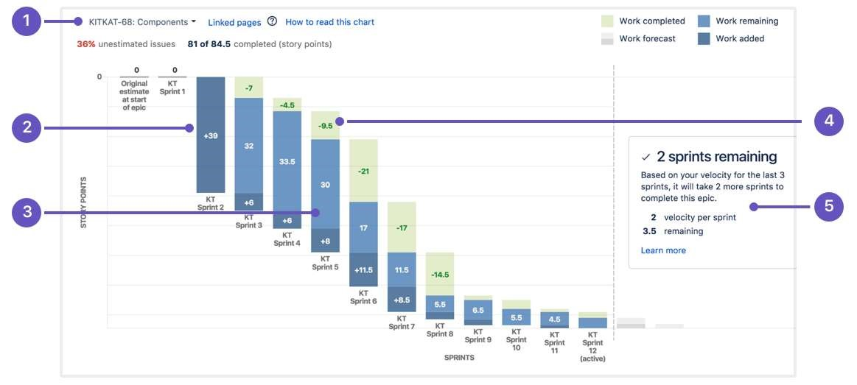

|  |
| --- |
| **SEP 22** |

|  |
| --- |
| **OCT 5** |

|  |
| --- |
| **OCT 27** |

|  |
| --- |
| **OCT 20** |

|  |
| --- |
| **SEP 25** |

|  |
| --- |
| **OCT 24** |

|  |
| --- |
| **OCT 12** |

